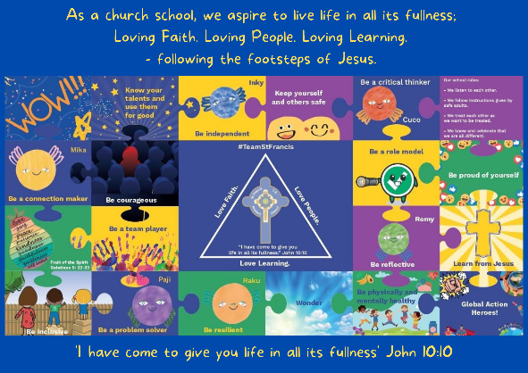
Personal, Social, Emotional, Health and Economic Education

St Francis PSHE Curriculum

Year 6 End points:
1. Being able to think things through and make good choices.
2. Having self-confidence and self-awareness.
3. Taking care of your physical health.
4. Keeping yourself and others safe.
5. Being community minded.
6. Having aspirational thoughts and the ability to plan for the future.
7. Being able to make and maintain healthy friendships.
8. Putting EDJ into practice.

In Year 2, we work on:
 | Big Question | PSHE Strand | End Point
Aut 1 | What helps us to stay safe? | Safety | 4. Keeping yourself and others safe.
Aut 2 | What is bullying? | Relationships | 8. Putting EDJ into practice.
Spr 1 | What makes a good friend? | Relationships | 7. Being able to make and maintain healthy friendships.
Spr 2 | What can help us grow and stay healthy? | Physical Health | 3. Taking care of your physical health.
Sum 1 | How can we communicate our feelings? | Mental Wellbeing | 1. Being able to think things through and make good choices.
Sum 2 | What jobs do people do? | Wider World | 6. Having aspirational thoughts and the ability to plan for the future.
