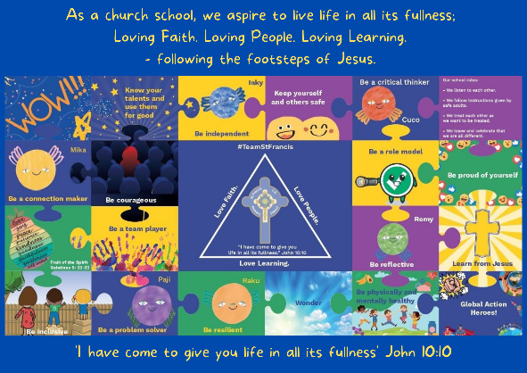
Personal, Social, Emotional, Health and Economic Education

St Francis PSHE Curriculum

Year 6 End points:
1. Being able to think things through and make good choices.
2. Having self-confidence and self-awareness.
3. Taking care of your physical health.
4. Keeping yourself and others safe.
5. Being community minded.
6. Having aspirational thoughts and the ability to plan for the future.
7. Being able to make and maintain healthy friendships.
8. Putting EDJ into practice.

In Year 4, we work on:
 | Big Question | PSHE Strand | End Point
Aut 1 | How do we treat each other with respect? | Relationships | 8. Putting EDJ into practice.
Aut 2 | How can we manage risk in different places? | Safety | 4. Keeping yourself and others safe.
Spr 1 | How can we develop healthy minds? | Mental Wellbeing | 1. Being able to think things through and make good choices.
Spr 2 | How can we take care of our physical health? | Physical Health | 3. Taking care of your physical health.
Sum 1 | What strengths, skills and interests do we have? | Mental Wellbeing | 2. Having self-confidence and self-awareness.
Sum 2 | How can our choices make a difference to others and the environment? | Wider World | 5. Being community minded.
